Real-time Motion Tracking of Abdominal Targets based on MRI

by

Tianyu Zhou

A thesis proposal submitted for BME1450 Bioengineering Science

IBBME Theme: Engineering in a Clinical Setting & Clinical Engineering

Institute of Biomaterials and Biomedical Engineering

MHSc. Clinical Engineering

University of Toronto

Supervisors:

Dr. James Drake,

Dr. Adam Waspe

November 4, 2016

**Abstract**

Neuroblastoma is the most common extracranial solid tumour in children 0-14 years of age. The proximity of sites of neuroblastoma to the renal artery poses challenges for conventional surgery. High-intensity focused ultrasound (HIFU) is a non-ionizing, non-invasive therapeutic technology that is particularly suited to thermally lesion internal abdominal targets, and is thus a promising alternative in treating neuroblastoma. Magnetic resonance (MR) thermometry provides real-time thermal mapping and dose calculations for monitoring the HIFU procedure. However, smaller targets of pediatric patients demand accurate HIFU monitoring to ensure the safety of healthy tissues in close proximity. Abdominal targets undergo a range of motions as well as non-rigid deformations, which give rise to artifacts in MR thermometry, and also demand for precise tracking of the HIFU focal point with the target. A hybrid method (Principal Component Analysis and Projection onto Dipole Fields, or PCA-PDF) has been shown to be feasible to correct for MR thermometry in real-time. However, more *in vivo* experiments are in need to validate this method. In addition, a method is needed to quantify the motions and deformations of the targets, and this method needs to be validated in *in vivo* HIFU treatments for clinical translation. This research will first validate the PCA-PDF motion compensation method. Then the traditional optical flow tracking technique will be adapted to current framework as the gold standard. Next, the learning-based fusion method will be implemented and optimized as the proposed solution. Both methods will be tested in *in vivo* experiments and their performances in accuracy, precision and speed will be compared. It is expected that all methods investigated will consistently meet the performance requirement of a real-time MRg-HIFU intervention, and that the learning-based fusion method will outperform the gold standard optical flow tracking method, in terms of accuracy, precision, and speed. The research will demonstrate the feasibility and safety of MRg-HIFU for non-invasive treatment of neuroblastoma. Results from this project will support the safe application of MRgHIFU in the abdomen and will lead to novel clinical studies using MRgHIFU for neuroblastoma in children.

Keywords: real-time MR-guidance, motion analysis, high intensity focused ultrasound

**1. Introduction**

Neuroblastoma is the most common extracranial solid tumour in children 0-14 years of age [1], forming most often in the adrenal gland or kidneys. Its proximity to the renal artery poses challenges for conventional surgery. High-intensity focused ultrasound (HIFU) is a non-ionizing, non-invasive therapeutic technology that is particularly suited for creating localized thermal ablation in diseased internal organs such as the kidneys, liver, pancreas, and spleen. HIFU is advantageous in treating pediatric neuroblastoma over conventional surgery, due to the following:

1. The smaller-sized anatomy of pediatric patients poses greater risk for conventional surgery, compared to larger adult-sized anatomy.
2. The HIFU beam is able to penetrate deeper into the tissue to reach the target anatomy in smaller patients.

However, there are also challenges with this technique. Smaller anatomical targets of pediatric patients demand accurate HIFU monitoring to ensure the safety of healthy tissues in close proximity.

Magnetic resonance (MR) thermometry provides real-time thermal mapping and dose calculations for monitoring the HIFU procedure, as well as signaling for the end point of the therapy. However, throughout the procedure, abdominal targets undergo a range of motions including respiratory motion, long-term motion (e.g. peristalsis), spontaneous motion (e.g. coughing, twitching) [2] as well as non-rigid deformations. These motions are responsible for artifacts in MR thermometry (data?). Moreover, the movements and deformations of the targets also make sustained sonication challenging, since dynamic repositioning of the HIFU focal point is required. Sustained sonication is preferred for highly perfused abdominal organs in order to achieve a sufficiently high temperature elevation to induce necrosis [3].

To correct for MR thermometry, a hybrid method has been designed and implemented that is able to achieve a temperature stability and precision of 0.85 °C and 1.00 °C, respectively, in *in vivo* porcine and human kidneys [4]. However, more *in vivo* experiments are needed to validate and streamline this method.

To facilitate dynamic refocusing of the HIFU beam in tracking the targeted organ, an automated method is needed to continuously quantify the organ motions and deformations. Previous studies have separately presented techniques for tracking of respiratory motion [2] and long-term motion [5], and method to bypass the scarce spontaneous motion [2]. However not all of the methods have been validated *in vivo*. Therefore, to address this knowledge gap, a solution to quantify organ elastic deformations in HIFU procedure will be developed. All of the motions and deformations need to be accounted for in one integrated solution platform to best estimate the overall target displacement. Furthermore, this platform will be validated through *in vivo* HIFU treatments for clinical translation.

**2. Research Question and Hypothesis**

*Research Question:* Can movement and deformation of abdominal targets be quantified in real time to facilitate focusing of the HIFU beam to track a target?

*Hypothesis:* Quantifying movement and deformation of abdominal targets in real time will enable the dynamic refocusing of the HIFU beam during *in vivo* treatments.

**3. Objectives**

The overall goal is to design, implement, refine, and evaluate a motion tracking algorithm to quantify abdominal organ movements and deformations during *in vivo* MR guided high-intensity focused ultrasound (MRg-HIFU) treatments.

Objective 1: Develop an integrated algorithm to quantify abdominal organ movements and deformations

Objective 2: Optimize the algorithm to achieve acceptable accuracy, precision and speed

Objective 3: Validate the algorithm through *in vivo* (MRg-HIFU) treatments.

**4. Literature Review**

Jeremy Tan completed his Master’s thesis entitled *Motion Compensation using Principal Component Analysis and Projection onto Dipole Fields for Abdominal Magnetic Resonance Thermometry* in 2016. His research focused on eliminating motion and susceptibility artifacts in MR thermometry that are caused by respiration (periodic) and peristalsis (aperiodic). In his study, a hybrid method was designed and implemented that combined principal component analysis (PCA) and projection onto dipole fields (PDF), both of which work on MR phase images without resorting to any external interaction or supplementary tracking tools. The method was shown to achieve a temperature stability and precision of 0.85 °C and 1.00 °C, respectively, in *in vivo* porcine and human kidneys [4].

In a recent study by Zachiu *et al*, an optical flow tracking technique that tracks respiratory motion was proposed. The proposed method improved upon the existing one based on the algorithm proposed by Horn and Schunck which assumes that pixels conserve their intensity along their trajectory, to which a spatial regularity constraint of the estimated motion is added. It was tested in the livers and kidneys of two healthy volunteers under free-breathing conditions. Results showed that: the new method demonstrated greater robustness to local grey-level intensity variations introduced by arterial pulsations and compatibility with real-time MR-guided beam interventions, including MRg-HIFU. A limiting factor of this study is that it will not be validated under realistic beam therapy scenarios [2].

Another recent study carried out by Zachiu *et al* exploited the episodic workflow of HIFU therapy to implement a motion correction strategy for long-term motion of the target area over the entire duration of the intervention. The authors proposed the integration of 3D MR scans in the therapy workflow during the inactivity intervals. Displacements were estimated using an optical flow algorithm applied on the 3D acquired images. A preliminary study was conducted on ten healthy volunteers and proved that slow physiological motion can exceed acceptable therapeutic margins. An *in vivo* experiment was conducted on a porcine liver, which validated the compatibility of the proposed motion correction strategy with the workflow of a MR-guided HIFU therapy under clinical conditions [5].

In a book chapter by Wang *et al*, a probabilistic framework was presented that relies on anatomically indexed component-based object models which integrate several sources of information to determine the temporal trajectory of the deformable target. Large annotated imaging databases are exploited to encode the domain knowledge in shape models and motion models and to learn discriminative image classifiers for the target appearance. The chapter demonstrates various medical image analysis applications with focus on cardiology such as 2D auto left heart, catheter detection and tracking, 3D cardiac chambers surface tracking, and 4D complex cardiac structure tracking, in multiple modalities including Ultrasound (US), cardiac Computed Tomography (CT), Magnetic Resonance Imaging (MRI), and X-ray fluoroscopy. Comparison studies were carried out in a 3D ultrasound and a 4D CT motion tracking cases that demonstrate better performance of the learning-based fusion method over the traditional optical flow method in accuracy [6].

**5. Methods**

This research will first validate the PCA-PDF motion compensation method. Then the optical flow tracking technique will be adapted to current framework, available in the lab, as the gold standard. Next, the learning-based fusion method will be implemented and optimized as the proposed solution. Both methods will be tested in *in vivo* experiments and their performances in accuracy, precision and speed will be compared. The phases of the research are detailed as follows:

**5.1. Phase 1 – Validation of PCA-PDF motion compensation method for abdominal magnetic resonance thermometry**

At least nine MRg-HIFU sonication experiments of abdominal targets in a healthy pig model are being conducted. Imaging is performed on Philips 3T Achieva scanner using 4mm regular cell. Datasets are collected during ventilated breathing and arrested breathing. Motion compensation software that implements the PCA-PDF algorithm will be run both online and offline. Datasets will be processed to evaluate the accuracy and precision of this particular algorithm, and its processing time will be calculated to determine its feasibility in real-time MRg-HIFU interventions.

Specifically, the aim of the algorithm is to achieve:

a) An accuracy of ± 1 °C within the targeted cell and to ± 3 °C in the periphery

b) A processing time, for a single dynamic, less than the dynamic scan time of the MR sequence of 573 ms [4].

**5.2. Phase 2 – Adaptation of optical flow tracking technique for tracking of respiratory motion and long-term motion (gold standard)**

An improved optical flow tracking technique, as proposed by <insert author’s name here>, will be adapted to the in-house Python framework [2]. The algorithm can be mathematically expressed with the following function [2]:



where Ω is the image domain, u and v are the components of the 2D displacement vectors and β is a user-defined weighting factor designed to link the data fidelity term (first term of the integral in equation) and the regularity of the estimated motion field (second term of the integral in equation). The minimization with respect to u and v will be done via the primal-dual algorithm [7]. Configuration parameters of the numerical scheme need to be tuned in order to ensure a fast convergence of the algorithm under various conditions in terms of noise/observed organ displacement amplitudes [2].

**5.3. Phase 3 – Implementation and optimization of learning-based fusion method**

A promising learning-based fusion method will be implemented in Python as the proposed solution. To obtain shape models, discriminative image classifiers for target appearance are trained in this framework, using marginal space learning (MSL) [8] and the probabilistic boosting-tree (PBT) [9], as illustrated in Fig.1.

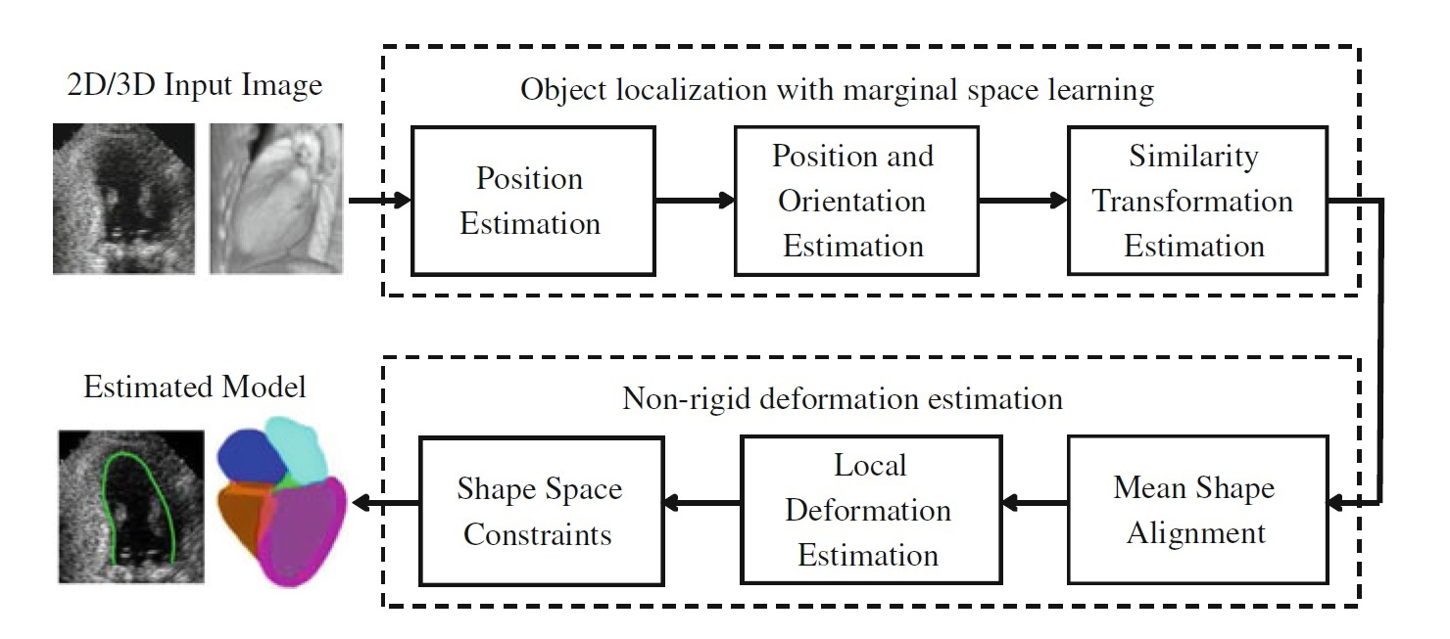

Fig. 1: Diagram for learning-based object detection and non-rigid deformation estimation [6]

To obtain motion models, manifold learning is then used to extract a compact form of the dynamic information [10].

Fused together, these lead to a nonparametric representation of the probability density function that characterizes the object appearance. Inspired by [11], tracking is performed by obtaining an independent motion estimate, from each model, and its uncertainty through a single probabilistic framework as follows:

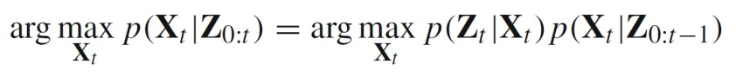

where **Z**0:*t* = **Z**0*, . . . ,***Z***t* are the image observations from the input image sequence *I*0:*t* = *I*0*, . . . , It* . In this framework, an anatomy-indexed mesh model is built to represent the object of interest. The block diagram of Fig. 2 summarizes the workflow.

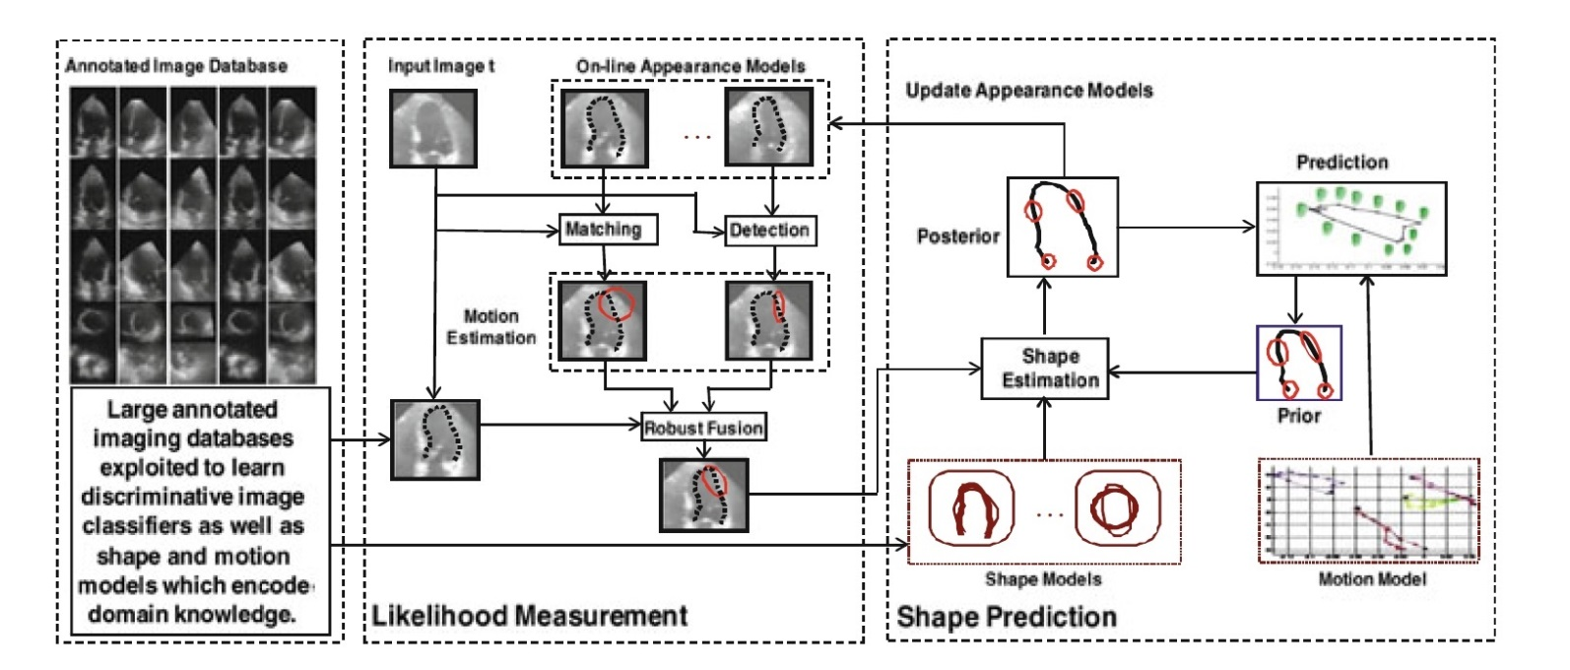

Fig. 2: A block diagram of the probabilistic motion estimation framework including the likelihood measurement and shape prediction processes [6]

After implementation, parameter tuning and optimization of the code will be carried out for accuracy, precision and speed.

**5.4. Phase 4 – Validation of learning-based fusion method with *in vivo* experiments**

The dataset obtained in Phase 1 will be used to test the learning-based fusion method. Accuracy and precision of the algorithm will be evaluated, and processing time will be calculated to determine its feasibility in real-time MRg-HIFU interventions. The algorithm aims to achieve, by voxel-wise estimation of displacement vectors, a consistent sub-voxel accuracy within 2.5×2.5×7 ${mm}^{3}$ voxel size [2]. Also it is aimed to have a processing time, for a single dynamic, well under the dynamic scan time of the MR sequence of 573 ms [4].

**6. Expected Results and Outcomes**

It is expected that all methods investigated will consistently meet the performance requirement of a real-time MRg-HIFU intervention. Specifically, the motion compensation method will achieve an accuracy of ± 1 °C within the targeted cell and to ± 3 °C in the periphery. Both of the motion tracking methods, optical flow tracking and learning-based fusion method, will achieve, by voxel-wise estimation of displacement vectors, a consistent sub-voxel accuracy within 2.5×2.5×7 ${mm}^{3}$ voxel size [2]. All of the motion compensation method and the motion tracking methods will have a processing time, for a single dynamic, well under the dynamic scan time of the MR sequence of 573 ms.

In addition, it is expected that the learning-based fusion method will outperform the gold standard optical flow tracking method, in terms of accuracy, precision, and speed.

**6.1. Progress and Timeline**

The timeline for this thesis is depicted in Appendix A. Progress to date includes conducting a literature review to gather background information and creating a preliminary thesis proposal.

**6.2. Dissemination Plan**

This project could potential yield two peer-reviewed publications or one large publication.

1. Validation of Motion Compensation using Principal Component Analysis and Projection onto Dipole Fields for Abdominal Magnetic Resonance Thermometry

2. Real-time Motion Tracking of Abdominal Targets based on MRI using a learning-based fusion method

These papers could potentially be published in the following journals:

• Journal of Magnetic Resonance Imaging

• Computerized Medical Imaging and Graphics

• Magnetic Resonance in Medicine

**7. Conclusions/Significance**

These experiments will help design and develop treatment protocols, including MR pulse sequences, and the sonication parameters for the MRgHIFU system. The research will demonstrate the feasibility and safety of MRg-HIFU for non-invasive treatment of neuroblastoma. The long-term goal of the project is to use focused ultrasound to noninvasively treat neuroblastoma clinically. Results from this project will support the safe application of MRgHIFU in the abdomen and will lead to novel clinical studies using MRgHIFU for neuroblastoma in children.

**References**

[1] Canadian Cancer Society, “Canadian Cancer Statistics Special topic : Predictions of the future burden of cancer in Canada,” Public Heal. Agency Canada, pp. 1–151, 2015.

[2] Zachiu C, Papadakis N, Ries M, Moonen C, de Senneville BD. An improved optical flow tracking technique for real-time MR-guided beam therapies in moving organs. Physics in medicine and biology. 2015 Nov 5;60(23):9003.

[3] Ries M, de Senneville BD, Roujol S, Berber Y, Quesson B, Moonen C. Real‐time 3D target tracking in MRI guided focused ultrasound ablations in moving tissues. Magnetic Resonance in Medicine. 2010 Dec 1;64(6):1704-12.

[4] Jeremy T, “Motion Compensation using Principal Component Analysis and Projection onto Dipole Fields for Abdominal Magnetic Resonance Thermometry,” M.S. thesis, IBBME, University of Toronto, Toronto, ON, 2016.

[5] Zachiu C, de Senneville BD, Moonen C, Ries M. A framework for the correction of slow physiological drifts during MR-guided HIFU therapies: Proof of concept. Medical physics. 2015 Jul 1;42(7):4137-48.

[6] Wang Y, Georgescu B, Chen T, Wu W, Wang P, Lu X, Ionasec R, Zheng Y, Comaniciu D. Learning-based detection and tracking in medical imaging: a probabilistic approach. InDeformation Models 2013 (pp. 209-235). Springer Netherlands.

[7] Chambolle A, Pock T. A first-order primal-dual algorithm for convex problems with applications to imaging. Journal of Mathematical Imaging and Vision. 2011 May 1;40(1):120-45.

[8] Zheng Y, Barbu A, Georgescu B, Scheuering M, Comaniciu D. Four-chamber heart modeling and automatic segmentation for 3-D cardiac CT volumes using marginal space learning and steerable features. IEEE transactions on medical imaging. 2008 Nov;27(11):1668-81.

[9] Tu Z. Probabilistic boosting-tree: Learning discriminative models for classification, recognition, and clustering. InTenth IEEE International Conference on Computer Vision (ICCV'05) Volume 1 2005 Oct 17 (Vol. 2, pp. 1589-1596). IEEE.

[10] Yang L, Georgescu B, Zheng Y, Wang Y, Meer P, Comaniciu D. Prediction based collaborative trackers (PCT): A robust and accurate approach toward 3D medical object tracking. IEEE transactions on medical imaging. 2011 Nov;30(11):1921-32.

[11] Comaniciu D, Zhou XS, Krishnan S. Robust real-time myocardial border tracking for echocardiography: an information fusion approach. IEEE transactions on medical imaging. 2004 Jul;23(7):849-60.

**Appendix A – Timeline**

|  |  |  |  |  |  |  |  |  |  |  |  |  |  |  |  |  |  |  |  |  |  |  |  |  |
| --- | --- | --- | --- | --- | --- | --- | --- | --- | --- | --- | --- | --- | --- | --- | --- | --- | --- | --- | --- | --- | --- | --- | --- | --- |
|  | 2016 | | | | 2017 | | | | | | | | | | | | 2018 | | | | | | | |
| S | O | N | D | J | F | M | A | M | J | J | A | S | O | N | D | J | F | M | A | M | J | J | A |
| Literature review |  |  |  |  |  |  |  |  |  |  |  |  |  |  |  |  |  |  |  |  |  |  |  |  |
| Write thesis proposal |  |  |  |  |  |  |  |  |  |  |  |  |  |  |  |  |  |  |  |  |  |  |  |  |
| HIFU experiments on pigs |  |  |  |  |  |  |  |  |  |  |  |  |  |  |  |  |  |  |  |  |  |  |  |  |
| Validate PCA-PDF method |  |  |  |  |  |  |  |  |  |  |  |  |  |  |  |  |  |  |  |  |  |  |  |  |
| Adapt optical flow technique |  |  |  |  |  |  |  |  |  |  |  |  |  |  |  |  |  |  |  |  |  |  |  |  |
| Implement LBF method |  |  |  |  |  |  |  |  |  |  |  |  |  |  |  |  |  |  |  |  |  |  |  |  |
| Optimize LBF method |  |  |  |  |  |  |  |  |  |  |  |  |  |  |  |  |  |  |  |  |  |  |  |  |
| Committee meeting #1 |  |  |  |  |  |  |  |  |  |  |  |  |  |  |  |  |  |  |  |  |  |  |  |  |
| Validate LBF method on pig dataset |  |  |  |  |  |  |  |  |  |  |  |  |  |  |  |  |  |  |  |  |  |  |  |  |
| Validate LBF method on human dataset |  |  |  |  |  |  |  |  |  |  |  |  |  |  |  |  |  |  |  |  |  |  |  |  |
| Write peer-reviewed publications |  |  |  |  |  |  |  |  |  |  |  |  |  |  |  |  |  |  |  |  |  |  |  |  |
| Write thesis |  |  |  |  |  |  |  |  |  |  |  |  |  |  |  |  |  |  |  |  |  |  |  |  |
| Presentation |  |  |  |  |  |  |  |  |  |  |  |  |  |  |  |  |  |  |  |  |  |  |  |  |
| Thesis defense |  |  |  |  |  |  |  |  |  |  |  |  |  |  |  |  |  |  |  |  |  |  |  |  |

Review of Thesis Proposal – 1 st draft

Reviewer Name: Arushri Swarup

Investigator Name: Tianyu Zhou

Peer Review Committee #: 9

Project Title: Real-Time Motion Tracking of Abdominal Targets based on MRI

Brief description of project (to be completed by reviewer):

This project will be developing an algorithm to quantify targets *in vivo* to focus a HIFU beam on a moving abdominal target. Using current technologies, PCA and PDF, an *in vivo* model will be validated after the algorithm is developed. As well, a learning based fusion method will be validated *in vivo* and will be compared to the optical flow tracking technique, which is the current framework.

In addition to your detailed comments and corrections within the document, please answer the following questions and provide explanations/suggestions where appropriate.

1. Are the objectives/research questions clear? Yes

2. Is the literature review appropriate and complete? Yes, but to clarify each piece of literature, explain its significance to objectives or hypothesis

3. Is the rationale for the study coherent and complete? Yes

4. Is the research innovative? Yes (as described by the knowledge gap)

5. Are the methods (design, measurement, analysis) appropriate to achieve the objectives? Yes - as seen in the plan and explanations

6. Are the expected study outcomes compelling and complete? Is there a dissemination plan and timeline? yes

7. Is the study feasible? yes

8. Is the organization of ideas clear and easy to follow? yes

9. Was the document easy to read and understand? Please use simpler language and simpler terms. Please write it as though explaining this to someone who is unfamiliar with the technology. I found some parts a little bit hard to understand because I am unfamiliar with the technology. Please see comments within the documents on how to clarify for the reader.

10. What is your overall assessment of the project? Well done and seems feasible to achieve for a Master’s

11. Please identify major issues and specific recommendations. See above comments. Overall it is a good idea and project, just needs to be written for someone unfamiliar with the subject.